**Food Express**



**Delicious Meals, Delivered Fast**

**Table of Content**

|  |  |  |
| --- | --- | --- |
| **CH.No** | **Title** | **Page no** |
| **I** | **INTRODUCTION** |  |
| **II** | **TECHNOLOGY STACK**   1. **Front end** 2. **Back end** |  |
| **III** | **SYSTEM DESIGN**   1. **Requirements** 2. **Structure layout**  * **Use case diagram** * **Class diagram** * **E-R diagram** |  |
| **IV** | **MODULES IMPLEMENTATION**   1. **User management** 2. **Home page** 3. **Registration page** 4. **Login page** 5. **Admin panel** 6. **Restaurant menu management** 7. **Order management** 8. **Feedback management** |  |
| **V** | **TESTING PROCESS** |  |
| **VI** | **CONCLUSION** |  |

**I.INTRODUCTION**

Our development project targets “Food Express” which creates an innovative food ordering application to provide convenient online services to both restaurant operators and their customers. Through this platform customers can search menus and place orders quickly and submit feedback as they use a simple and easy-to-navigate user interface. Through this system restaurant owners gain complete control of their menu offerings while they can monitor the entire order process from real time through their centralized interface for quick delivery management.

The addition of automated order management systems and secure payments and real-time alerts combined with detailed reporting tools through “Food Express” will enhance operational efficiency and elevate customer satisfaction levels. Analytics built into the platform empower restaurant managers to base their choices on data and enhance menu performance through analytics as well as grasp their customers' preferences. The “Food Express” platform targets new benchmarks in online food ordering through its well-built technology framework combined with easy-to-use design properties which unite technology with customer satisfaction enhancements.

**II.TECHNOLOGY STACK**

**1.Front end**

Applications feature their user interface along with every element through which users engage directly in their frontend section. An application's frontend contains design principles joined with layout features and navigation components and application content principles which maintain a seamless user experience. Food Express application delivers its customers and restaurant owners and administrators with an interactive seamless platform through its critical frontend component. The frontend platform permits customers to browse menus, order food and offer feedback along with order status tracking through an interface with simple navigation. Business owners and administrators get access to management dashboards which help them manage menu items and view orders as well as build reports. The platform achieves data retrieval and real-time display through its frontend/backend interaction to deliver the most recent available information to users. A visually pleasing design alongside device compatibility and intuitive interface make the frontend improve both the operational capabilities and end-user satisfaction on the Food Express platform.

**Tools used in Front-end ;**

**Thymeleaf**

Thymeleaf operates as a contemporary Java technology that provides server-side rendering to create dynamic web pages in Java applications. Through templates developers embed server-side data to generate dynamic HTML and XML and JavaScript and CSS content thus it works well for applications which need real-time updates in content. With natural templating Thymeleaf lets developers work through HTML files that remain valid HTML since this approach enables designer-developer collaboration. In addition to working with Java Spring Boot and Spring MVC frameworks it supports sophisticated features for conditional rendering as well as loops and form management and internationalization capabilities. Thymeleaf establishes itself as a versatile tool for creating web applications that handle interactive data through its valid HTML templates.

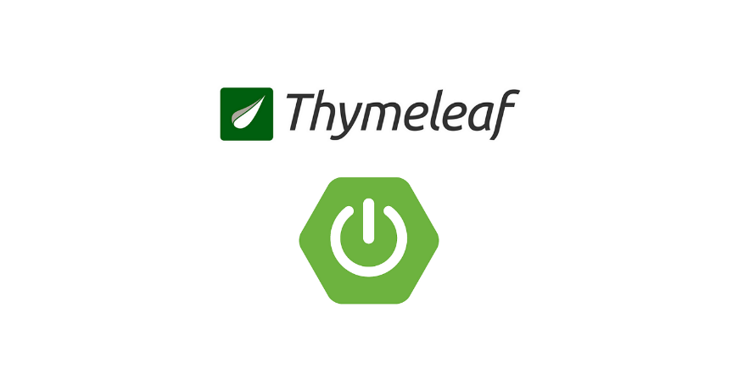

**Fig.Thymeleaf**

The main usage of Thymeleaf inside Food Express occurs for frontend content generation. The Food Express application relies on Thymeleaf to deliver dynamic front-end content. Thymeleaf will function as the template engine to produce HTML pages which show live data concerning restaurant menus and customer orders and feedback. The restaurant menu gets its content from the backend through dynamic population by Thymeleaf so customers can view and personalize their orders. Through Thymeleaf the system will show order status information in addition to processing both customer feedback and displaying reports which are intended for restaurant owners and administrators. The Food Express application achieves interactive and responsive page delivery by using Thymeleaf templates integrated with Spring Boot. The forms for placing orders and submitting feedback will be handled through Thymeleaf which enhances the efficiency of the user interaction flow.

**2.Backend**

An application backend consists of server-side components which handle necessary functionality including logical operations and database management. The backend role involves the control of data as well as request processing from front-end operations and mathematical calculation execution and data storage alongside protection of data security and system performance. Backend infrastructure includes databases together with server networks, application programming interfaces and server programming that allows the frontend to request and transmit data.

Food Express application backend executes activities that encompass data storage for customers and order processing and menu maintenance and payment management with report creation capabilities. The application relies on Spring Boot to construct RESTful services and MySQL together with alternative databases to store information besides utilizing different backend operating procedures that maintain frontend-server data communication. A dynamic server infrastructure located out of sight will maintain application functioning and data transmission to users while processing operations accurately and swiftly.

**Tools used in Back end ;**

**(i). Java Eclipse IDE**

The Eclipse Integrated Development Environment stands out as a major development platform that developers extensively use to create Java applications. Eclipse delivers an elaborate toolset alongside numerous features which enhance developer experience so users can produce and monitor and digest Java applications more readily. Eclipse provides a code editor consisting of features such as syntax highlighting in addition to code completion tools and built-in debugging abilities and refactoring tools that facilitate developers to write clean, efficient and error-free code. The IDE functions with various programming languages and frameworks through plugins where Java stands out as its main strength because Eclipse provides strong support for running Java Development Kits (JDK) and seamlessly integrates with Maven and Gradle project management tools and build automation systems.

Developers use Eclipse for Food Express application creation since it functions as the main development platform for complete back-end and front-end development activities. Through Eclipse developers can implement Java code using Spring Boot framework to establish server-side APIs and process data while maintaining database connectivity (MySQL is an example) Using Eclipse developers can simplify managing JDBC database connections and conduct relational mapping through JPA integration.

The combination of Eclipse and Thymeleaf templates operating through Spring Boot facilitates frontend development and testing work for Food Express. The tool gives developers the ability to maintain dynamic web page design and active preview functionality which verifies how user-interface elements will appear to end users. Through Eclipse developers get the advantage of Git version control to work together on separate sections of application code.

Food Express depends on Eclipse to offer an extensive development management environment through which developers can construct and test the application while ensuring error-free implementation of backend services and frontend UI.



**Fig.Eclipse**

**(ii). MySQL**

Developers use MySQL as an open-source relational database management system (RDBMS) which operates through Structured Query Language (SQL) to handle data storage and management and retrieval needs. Websites use this system extensively for web applications because it delivers reliable service with high performance at the same time makes operations easy to handle. The MySQL system uses established table structures to maintain data relationships and supports database transactions and indexing functions together with security features. The system integratesMySQL through technologies that include Java, PHP and Spring Boot. The Food Express application employs MySQL to store essential data including customer information as well as restaurant menus and orders and customer feedback which guarantees reliable and efficient data management.

The Food Express application relies on MySQL to handle the complete database management of different forms of application data. The system organizes all organized tables which include customer details, restaurant menus, orders, feedback and reports while managing their storage process. Through SQL queries MySQL enables the application to perform real-time data operations across this database which supports order processing along with menu updates and feedback management. The database ensures fast and secure storage and retrieval of data because of its performance levels which support both the efficient platform operation and smooth user experience on Food Express.

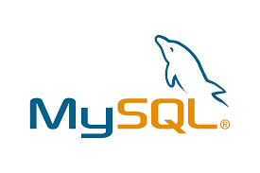

**Fig.MySQL**

**(iii). Spring Tool Suite (STS)**

STS serves as an Eclipse-based development environment which specializes in creating Spring-based programs. STS improves the development workflow because it features developer tools that are perfectly suited for Spring projects which encompass Spring Boot, Spring MVC, and Spring Data. STS offers its users project templates alongside Spring configuration completion and enables integrated debugging tools and simple Spring Boot application management. The IDE offers the ability to test as well as debug applications and provides smooth integration with Spring Cloud development for micro services creation. STS proves valuable to Java developers who work with Spring Framework since it boosts their development pace and application management efficacy.



**Fig. Spring tool suite**

**III. SYSTEM DESIGN**

Application designing demands systematic steps for planning the system's structure as well as modeling it prior to development initiation.

**1.Requirements;**

Users can access the Food Express application for an easy online food ordering journey. The Food Express application needs user management for profile creation and order tracking and secure login features and restaurant menu management functions for adding and updating menu items. The order management system needs to let customers view menus and create new orders and provide instant order updates. Users through Feedback management will provide assessment features to restaurants and restaurant owners can access review responses. The Reports management function gives owners and administrators access to inspect sales statistics and track orders together with reading customer feedback. The system prioritizes non-functional demands by incorporating excellent performance alongside extensive security provisions and the capacity to scale up and maintain operational ease across multiple platforms with extensive privacy and uptime features. The system aims to provide users with needed features and maintain operational efficiency for restaurants as well as delivering scalable platform functionality.

**2.Structure layout ;**

The Food Express application arranges different components and interface elements through its structure layout. This section includes the basic design of the program that shows how User Management interfaces with Menu Management while connecting to Order Management alongside other application components. The design provides users with one continuous process starting from menu browsing up to order placement alongside feedback submission. A clean interface design and intuitive navigation system with simple sections should be present for both customers and restaurant owners. The backend elements work together through smooth data transmission between database and APIs to interface while enabling real-time order monitoring and report making. The application runs optimally with good structure layout and also achieves better scalability while maintaining proper user experience.

Several types of diagrams are used in the design phase to visualize different aspects of the application, ensuring clarity and efficiency.

* **Use case diagram**

A **Use Case Diagram** visually represents the interactions between users (actors) and the system, illustrating the system’s functionality from the user’s perspective. It helps identify and organize the different ways users will interact with the application, such as placing orders, managing menus, and giving feedback. Use case diagrams are useful for understanding system requirements, defining user roles, and ensuring that all necessary functionalities are covered in the application design.

**Fig. Use case diagram**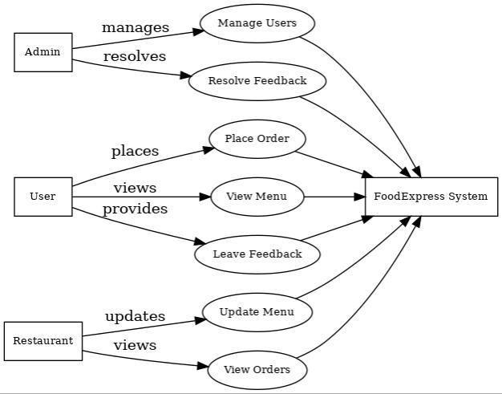

* **Class diagram**

A Class Diagram represents the structure of an application by showing the classes, their attributes, methods, and the relationships between them. It helps in organizing and visualizing the system’s object-oriented design, allowing developers to understand how different components (such as users, orders, and restaurants) interact within the system. Class diagrams are essential for defining the system’s data model and supporting efficient development and maintenance.

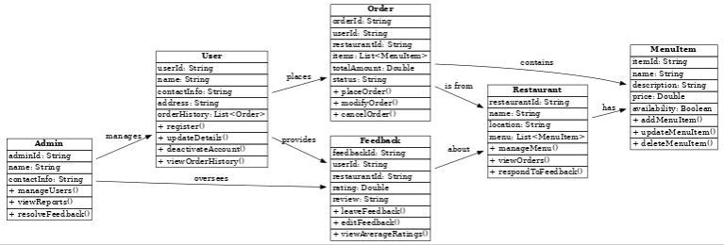

**Fig. Class diagram**

* **E-R diagram**

An Entity-Relationship (ER) Diagram is used to model the data structure of an application by showing the entities (such as users, orders, restaurants) and the relationships between them. It helps in designing and visualizing the database schema, ensuring that data is organized efficiently and relationships are properly defined. ER diagrams are essential for understanding data flow, improving data integrity, and guiding the development of the backend database.

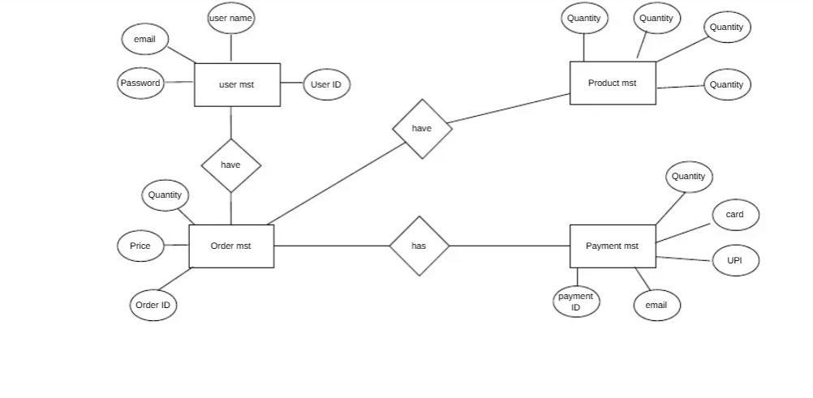

**Fig. Entity Relationship Model**

**IV.MODULES IMPLEMENTATION**

**1.User Management**

The Food Express application through User Management provides a system for customer registration and authentication services and profile maintenance. The system enables users to establish new accounts and obtain safe access to their accounts alongside profile information updates including contact information and delivery addresses. Through the application customers gain access to their previous orders and ongoing orders and they also control their profile settings. Secure login to the system happens through users' email accounts.

**(i).Homepage design;**

The FoodExpress application presents its Homepage as the main entry point which creates a user-friendly and appealing interface for visitors.

**Header:**

* Users recognize the FoodExpress brand through its logo combined with its name display.
* Navigation menu for Home, Restaurant Menu, Orders, Feedback, and Profile.
* A Login/Signup button together with a user profile icon lets users access their account without delay.

**Search Bar:**

* The search function appears at a visible position for users to select restaurants or food products swiftly.
* Users can apply filters to refine their choices through categories of food type or ratings system and service type availability.

**Main Banner:**

* The main display presents a visually stunning image that features well-liked dishes along with current promotional deals.
* Two clickable buttons allow users to navigate to Explore Menu or Browse Restaurants.

**Featured Restaurants or Cuisines:**

* Users can view a scrollable portion that shows featured restaurants alongside their images alongside brief descriptions.
* Users can find direct access to well-liked and trending restaurants through the interface.

**Special Offers:**

* This section should include promotional deals alongside discounts in order to stimulate orders from customers.

**Footer:**

* Links to customer support, terms of service, privacy policy, and social media handles.
* The system features an option that lets users choose between various regions including language settings.

The homepage features a user-friendly interface together with clear navigation paths that leads users to vital features for an optimal experience involving restaurant owners and customers.

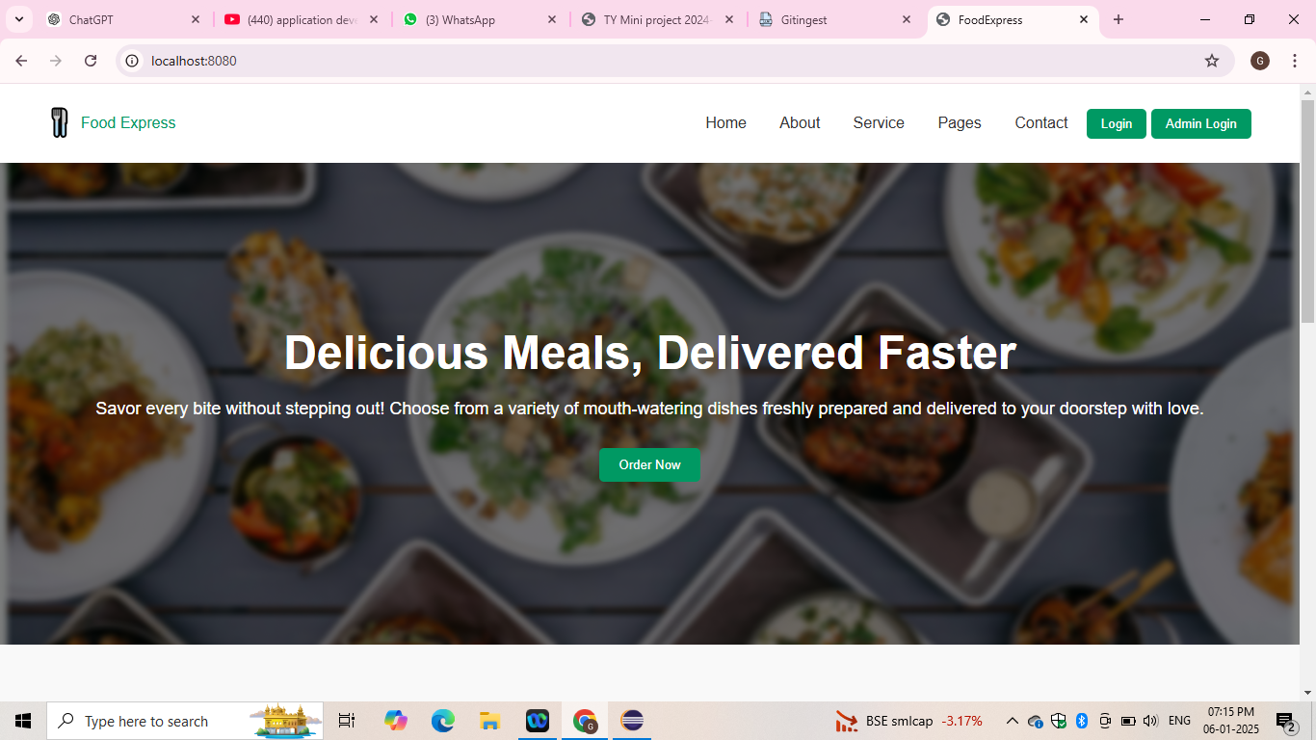

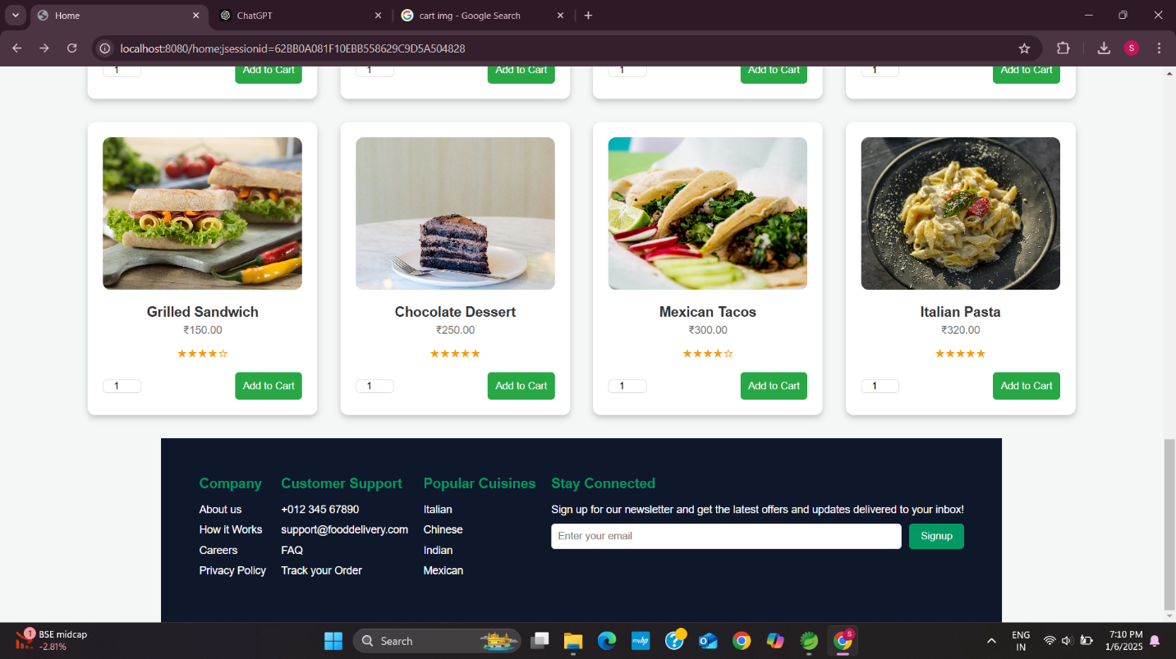

**(ii).Registration Page;**

Users can establish their Food Express account during registration by supplying their necessary information which includes name along with email and password and delivery address. This interface uses validation tests for proper data entry and provides security measures for creating passwords. Users who register through the system receive their exclusive profile interface and become able to make purchases and observe order progress while controlling account settings.

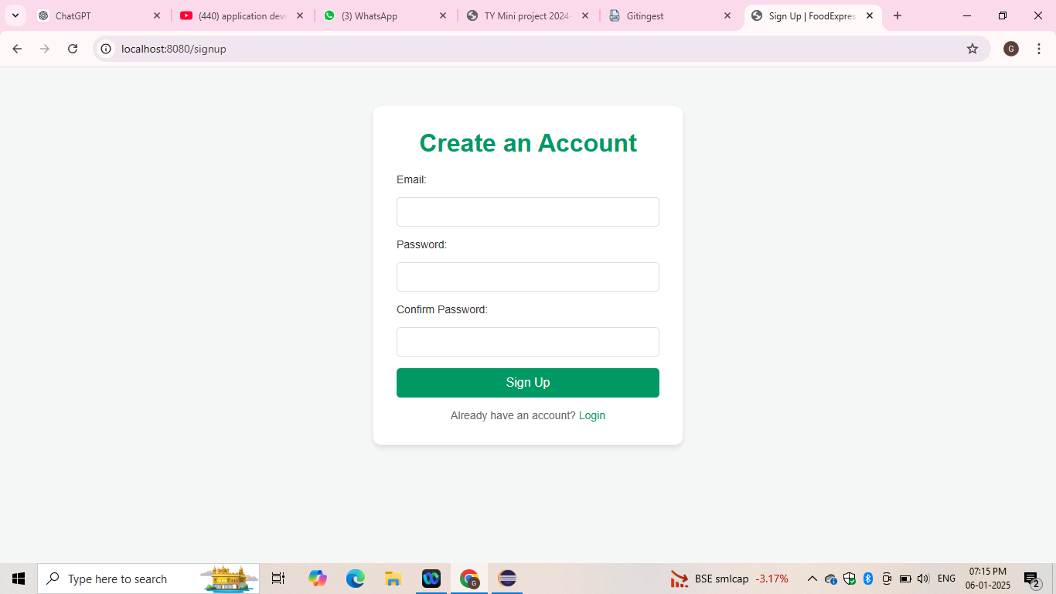

**(iii).Login page:**

Food Express application users who registered can use the Login Page to gain secure access with their email and password combination. Users can recover their forgotten password through the provided “Forgot Password” link. User authentication works securely on the page before the system moves users to their personalized dashboard after a successful login. Existing users can register on the same page when they need to create a new account through the application.

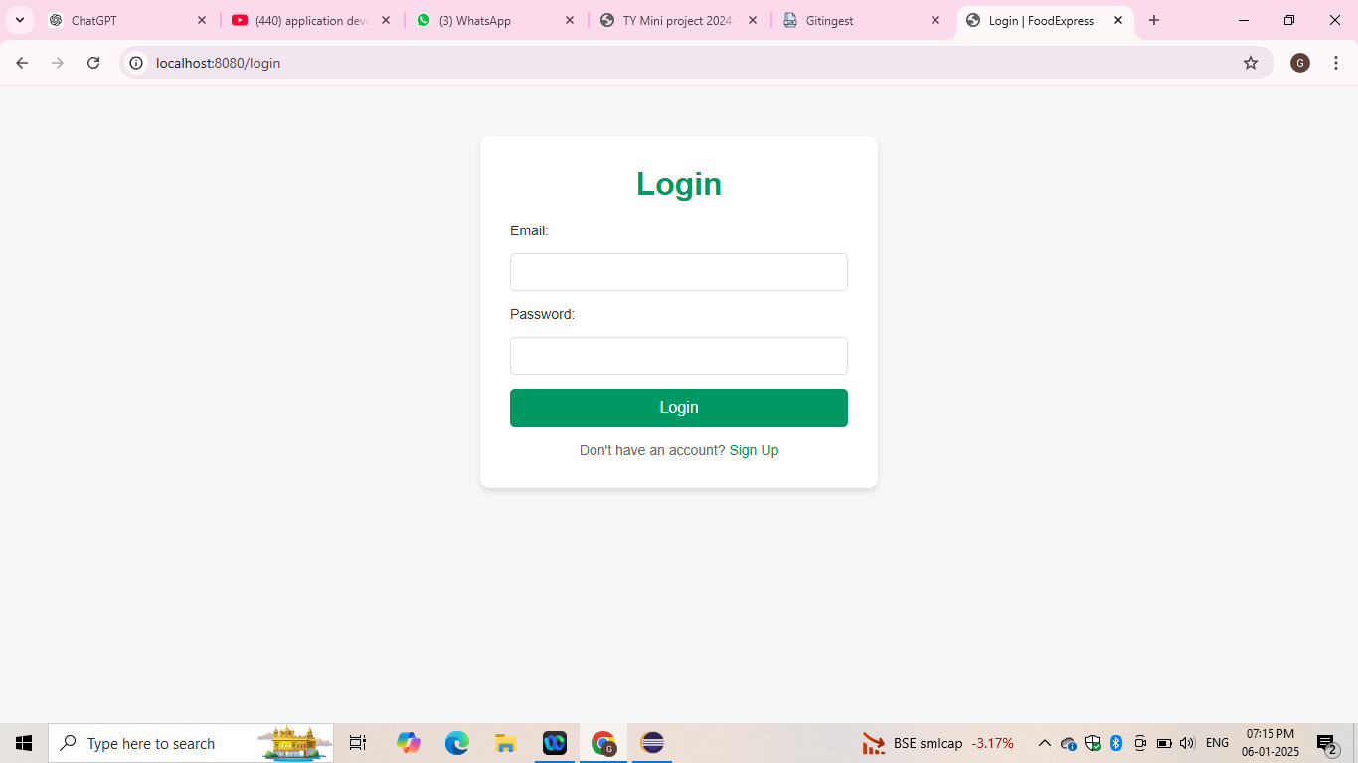

**(iv).Admin panel:**

The Food Express application includes an Admin Panel which gives administrators full authority to manage all operations throughout the platform. Through this system admins have full control to manage all aspects of customer accounts and restaurant listings along with order transactions. The panel provides administrators capabilities to oversee restaurant menu updates and restaurant approvals and service feedback management to maintain service quality. Administrators receive analytical information from the system which includes details about sales performance and order frequency together with customer feedback data. With its administrative feature the system allows businesses to manage payment gateways along with promotional discounts and delivery options which ensure the application operates to meet organizational targets.

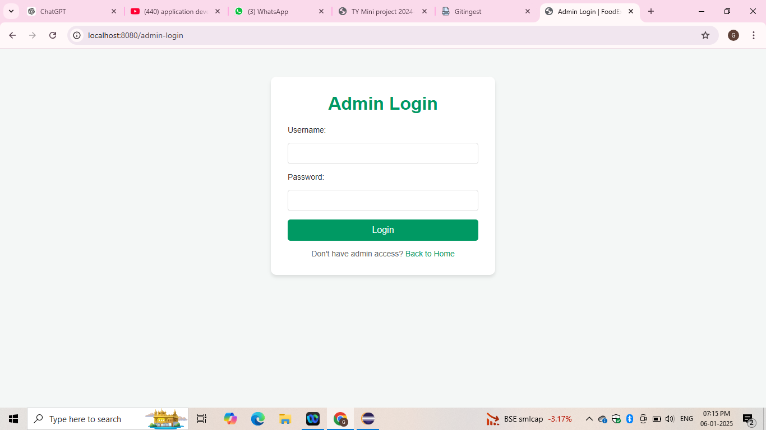

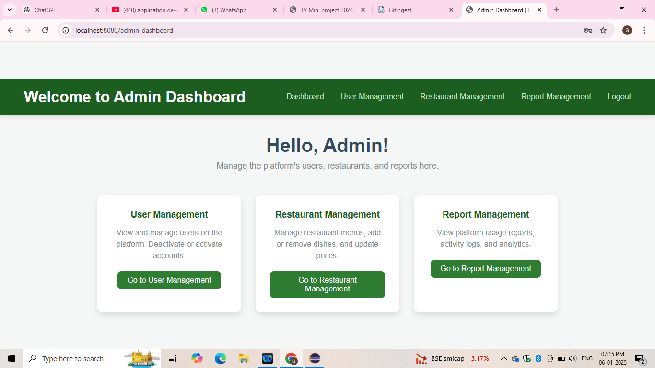

**2.Restaurant Menu management**

The Food Express application provides Restaurant Menu Management that allows owners to handle their menus through updates and additions or deletions of items effectively. The application allows restaurant owners to maintain a current menu through its feature which adds essential information including names and prices and descriptions and pictures of dishes. Restaurant owners achieve easy menu navigation through filters which they can pair with item classification by type like appetizers and main courses and desserts. Customers can access updated menu information in real-time because the system performs automated updates along with other features. A well-designed menu management system allows users to find dishes easily which results in better order processing.

**3.Order management**

FoodExpress Order Management operates to make food ordering seamless by showing all restaurant names together with dish prices and ratings alongside promotional offers. Custom customers can view menus then select items to their cart followed by customization and checkout procedures using different payment choices. The platform presents customers with restaurant listings that show names together with ratings and user reviews for deciding between options. After updating the cart the payment option need to complete. They can pay the bill using the credit / debit cards. After payment we received the payment receipt.

**4.Feedback management**

The FoodExpress application enables its customers to review restaurants and food items through Feedback Management features based on their dining experiences. Each rating and review and sharing of customer feedback pertaining to food quality and delivery time and service is managed through the FoodExpress application by users. The Feedback Management system in FoodExpress enables both customers and restaurants to assess and handle user feedback which helps establishments maintain their quality while refining their services. The system evaluates aggregated ratings to provide complete restaurant scores which helps different users decide between restaurants. Feedback analytics enable restaurant owners to assess client satisfaction thus helping them identify service enhancement possibilities that lead to superior dining encounters for their users.

**V. TESTING PROCESS**

The testing procedure for ensuring correct FoodExpress application operation includes a stepwise evaluation of main features alongside confirmation of their target outputs.

**1. Sign-In/Sign-Up Verification:**

* The application can be accessed by opening it to visit the Login page.
* The user can continue to the homepage when entering proper credentials.
* An incorrect credentials test should be conducted to confirm the system shows an error message.
* The testing process should include a verification step for the Sign-Up functionality through the creation of a new user account which should transmit a confirmation after registration.

**2. Restaurant Menu Browsing:**

* Examine the Menu Page to confirm that all restaurant names, food items with prices and available promotional offers display properly.
* Users should examine search bar and filter conditions because they should generate appropriate results.

**3. Cart addition and order completion :**

* Users should choose their desired food items then move them to the shopping cart.
* After adding items to checkout users should provide payment information before concluding the payment transaction.
* An order confirmation notification should appear while simultaneously storing all order information.

**4. Feedback Submission:**

* The users can provide the reviews & their feedback about the ordering process and the food quality , services and etc..
* This helps to improve the services.

**5. Admin & Restaurant Owner Functions:**

* Verify that an Admin user has full access to User Management, Order Management and Reports during login.
* The Restaurant Owner role should enable testing of menu item operations including new additions and content modifications and deletions.

**6. Logout & Security Testing:**

* Navigate to the Logout button followed by confirmation of the login page redirection.
* Users should authenticate restricted pages after logout to verify that they automatically route to the login screen.

The tests verify the proper operation of all core functionalities within the FoodExpress application for both users and restaurant owners and administrators.

**VI. CONCLUSION**

Developing the FoodExpress application provides enrichment for our team because we implemented an online food ordering platform from scratch. The implemented essential system components included user management together with restaurant menu management and order processing along with feedback collection and report generation to deliver an efficient experience to customers and restaurant owners. A reliable system based on backend development through Spring Boot and frontend rendering with Thymeleaf and MySQL database management created a scalable solution for real-time transactions with users.

We received practical experience with creating complete interactive software systems including database architecture development alongside API implementation and testing methods. Our team handled multiple obstacles including security of authentication processes and optimization work on tracking orders and user interface response times. Our skills in problem-solving along with our comprehension of software development standards increased through this project.

The FoodExpress system proves to be more than merely a practical food ordering platform because it showcases our complete capability for creating and deploying actual software infrastructure. The technical and professional skills learned while working on this application will prove essential when developing future user-oriented scalable projects.